7. Reverse Integer

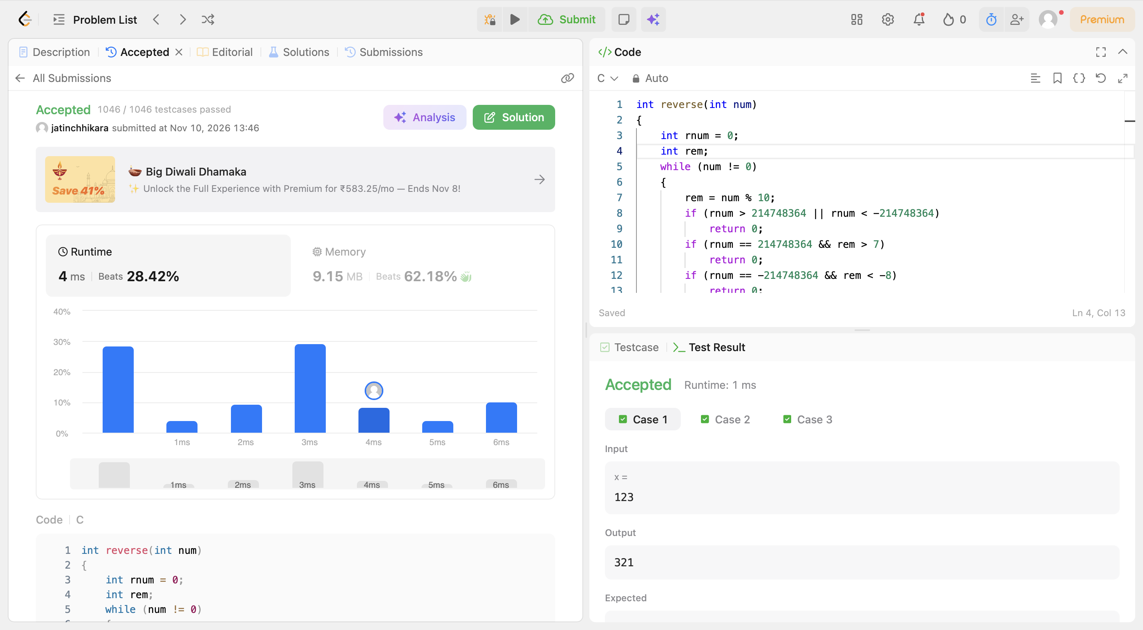
Code:
int reverse(int num)
{
int rnum = 0;
int rem;
while (num != 0)
{
rem = num % 10;
if (rnum > 214748364 || rnum < -214748364)
return 0;
if (rnum == 214748364 && rem > 7)
return 0;
if (rnum == -214748364 && rem < -8)
return 0;
rnum = rnum * 10 + rem;
num = num / 10;
}
return rnum;
}

